Creating Hello World Example

Let's create the hello java program:

**class** Student {

**public** **static** **void** main(String args[]){

     System.out.println("Hello MCA");

    }

}

Save the above file as Simple.java.

|  |  |
| --- | --- |
| **To compile:** | javac Student.java |
| **To execute:** | java Student |

**Output:**

Hello MCA

**Compilation Flow:**

When we compile Java program using javac tool, the Java compiler converts the source code into byte code.

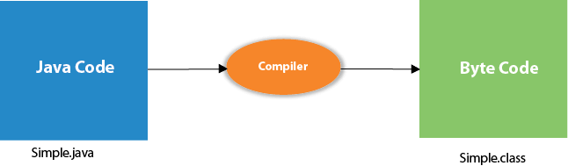

## **Parameters used in First Java Program**

Let's see what is the meaning of class, public, static, void, main, String[], System.out.println().

* **class** keyword is used to declare a class in Java.
* **public** keyword is an access modifier that represents visibility. It means it is visible to all.
* **static** is a keyword. If we declare any method as static, it is known as the static method. The core advantage of the static method is that there is no need to create an object to invoke the static method. The main() method is executed by the JVM, so it doesn't require creating an object to invoke the main() method. So, it saves memory.
* **void** is the return type of the method. It means it doesn't return any value.
* **main** represents the starting point of the program.
* **String[] args** or **String args[]** is used for [command line argument](https://www.javatpoint.com/command-line-argument). We will discuss it in coming section.
* **System.out.println()** is used to print statement. Here, System is a class, out is an object of the PrintStream class, println() is a method of the PrintStream class. We will discuss the internal working of [System.out.println()](https://www.javatpoint.com/system-out-println-in-java) statement in the coming section.